INTRODUCTION TO VIRTUALIZATION AND CLOUD COMPUTING LAB

• AIM: Create type 2 virtualization in VMWARE. Allocate memory and storage space as per requirement. Install Guest OS on that VMWARE.

1. What are Virtual Machines?

Virtual machine is a software computer that, like a physical machine, runs an operating system and applications.

A virtual machine uses the physical resources of the physical machine on which it runs, which is called the host system.

Virtual machines have virtual devices that provide the same functionality as physical hardware, but with the additional benefits of portability, manageability, and security.

You use the New Virtual Machine wizard to create a new virtual machine in Workstation. The wizard prompts you to make decisions about many aspects of the virtual machine.

We should Installation of VMware on windows 10 make these decisions before you start the New Virtual Machine wizard.

The steps are as follows:

STEP 1: open VMware Wizard:

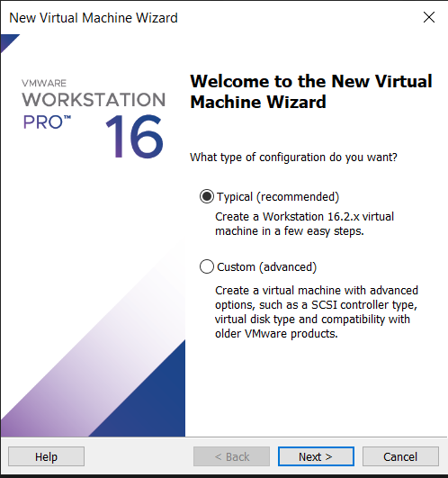

STEP 2: Click next in the VMware setup wizard

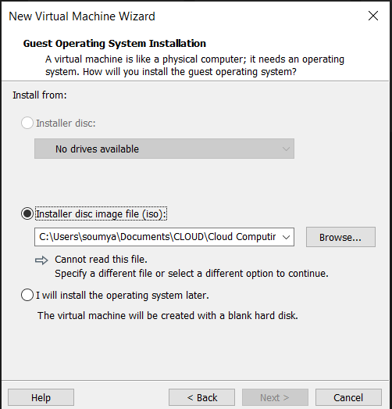

Step 3: Click the checkbox to accept the VM end-user license agreement and press the next button

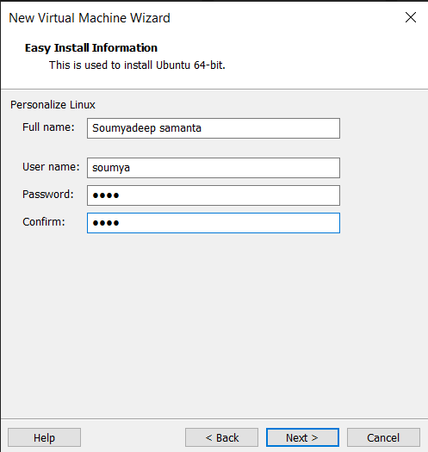

Step 4: The custom setting window will open to select the installation destination and any additional features. C drive will be selected by default. Click Next to proceed further.

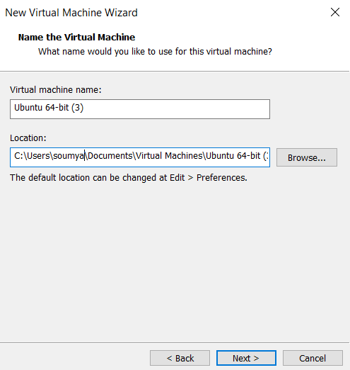

Step 5: Click next in the user experience setting.

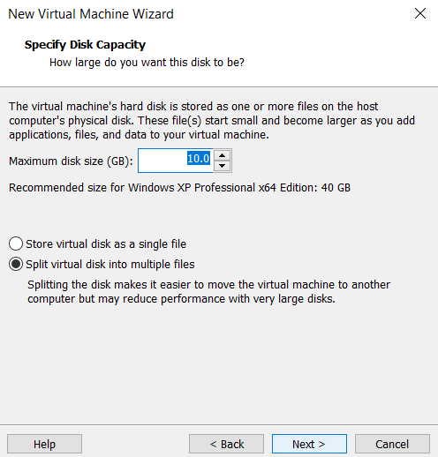

Step 6: The shortcuts window will open which will enable you to place the VM shortcut anywhere you wish to place on the system

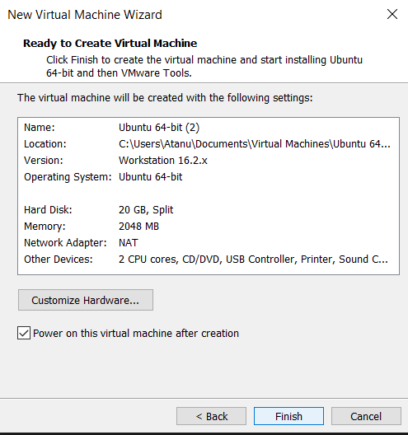

Step 7: After finishing the installation restart the system and while restarting the system continuously press f9 to open the system boot manager

Step 8: Selecting a virtual machine configuration – When you start the New Virtual Machine wizard, the wizard prompts you to select a typical or custom configuration.

• Typical Configuration

How you want to install the guest operating system. – If you select a typical configuration, you must specify or accept defaults for a few basic virtual machine settings.

A name for the virtual machine and a location for the virtual machine files.

The size of the virtual disk and whether to split the disk into multiple virtual disk files.

Whether to customize specific hardware settings, including memory allocation, number of virtual processors, and network connection type. • Custom Configuration

Create a virtual machine that has a different Workstation version than the default hardware compatibility setting. – You must select a custom configuration if you need to perform any of the following hardware customizations.

Select the I/O controller type for the SCSI controller.

Select the virtual disk device type.

Configure a physical disk or an existing virtual disk instead of create a new virtual disk. Allocate all virtual disk space rather than let disk space gradually grow to the maximum disk size.

